VISIT TO KNOWSLEY HALL, Merseyside, the home of the 19th Earl and Countess of Derby on Thursday 12 May 2022 from 12.30-5.00pm. Lunch included.

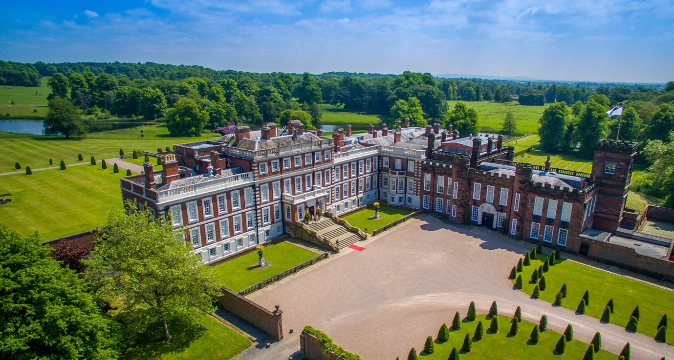

As part of our 70th year celebrations, don’t miss this opportunity to visit Knowsley Hall, the magnificent stately home of Lord and Lady Derby, which is rarely open to the public. Dr Stephen Lloyd, Curator of the Derby Collection and Attingham alumnus, will lead a private tour around this great mansion set in a ‘Capability’ Brown landscape, with its complex architectural history dating from 1385 and stateroom interiors designed in a variety of historic styles between 1890 and 1913. Exceptionally for us, we will see the Royal Lodgings constructed in 1495 and the Steward’s Room, with some of the silver horseracing trophies, and a special display in the Library of natural history watercolours alongside archives and plans relating to the history of the Derby Collection.

The cost of the private visit with hot lunch included is £40
Travel to Knowsley is not included.
A £10 donation to the 70th Attingham Anniversary scholarship would be greatly appreciated

Deadline date for booking is 22 April 2022

To book a place, please contact Rebecca Parker: rebecca.parker@attinghamtrust.org

TRAVEL
- If coming by car, a map will be supplied. The suggested satnav postcode is L34 4AJ (George Hale Avenue). This will ensure arrival at the correct entrance to the Estate.
- If coming by train from London, the suggested route is
Outward: 10.07 Euston Station to Runcorn arrival at 12.01
Return: 18.04 Runcorn to Euston arrival 20.03
Please let Rebecca know asap if you are coming by train. If we have sufficient numbers, we will organise taxis/minibus in advance so that the cost of £30-40 from Runcorn to Knowsley can be shared.

